**API DOC**

**MATCHES SCREEN**

GET request to display matches on the screen:

{

    "matchesId":12,

    "matchTitle":"title",

    "matchDestination":"India - Hyderabad",

    "startsTime":"312321",

    "enterFee":"20B",

    "joinAvailable":10,

}

1. startTime is expected in seconds
2. JoinAvailable will decide whether user can proceed to buy / get another ticket for the raceid

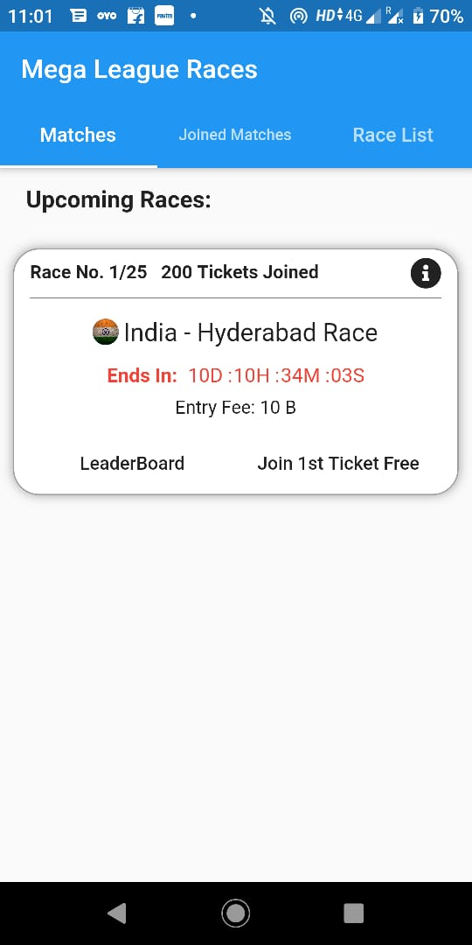

POST resquest to add races to joined matches

{

    "matchesId":12,

    "tickets":5

}

1. After this I’ll be calling get Matches to and get joined matches Api

GET request joined matches

{

    "joinRaceId":12,

    "raceTitle":"title",

    "raceDestination":"India - Hyderabad",

    "startsTime":"312321",

    "enterFee":"20B",

    "ticketsPurchased":5,

}

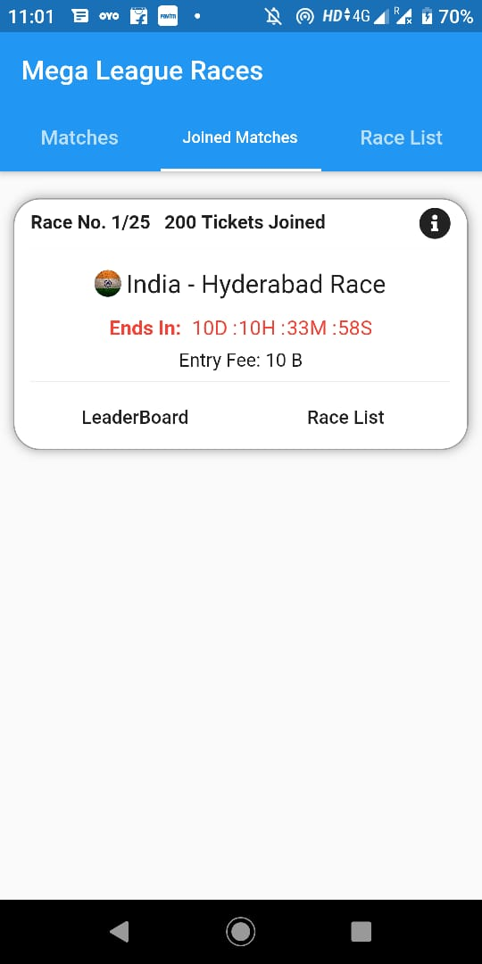

GET Race List for particular RaceId

{

  "joinRaceId": 12,

  "raceListId": 1,

  "title":"Hyderabad - Race 1(140M)",

  "startTime":1232132,

  "raceResult":"1st - 2/2nd...."

}

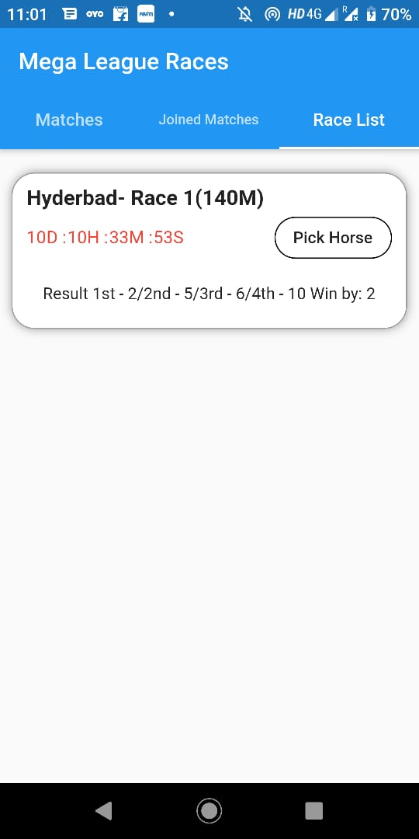

GET request for particular raceListId to pick horses

{

  "raceListId":1,

  "raceId":10,

  "raceTitle":"Hyderabad - Race 1",

  "tickets":[

      {

        "ticketId":1,

        "ticketBudget":15000

      },

      {

        "ticketId":2,

        "ticketBudget":15000

      }

  ],

  "horses":[

      {

          "horseId":1,

          "title":"moonlight raomance",

          "totalCr":1200,

          "jockey":"xyz",

          "Trainer":"xyz",

          "pts":350,

          "percentage":"25%"

"withdrawn":false

      },

      {

          "horseId":1,

          "title":"moonlight raomance",

          "totalCr":1200,

          "jockey":"xyz",

          "Trainer":"xyz",

          "pts":350,

          "percentage":"25%",

"withdrawn":true

      }

  ]

}

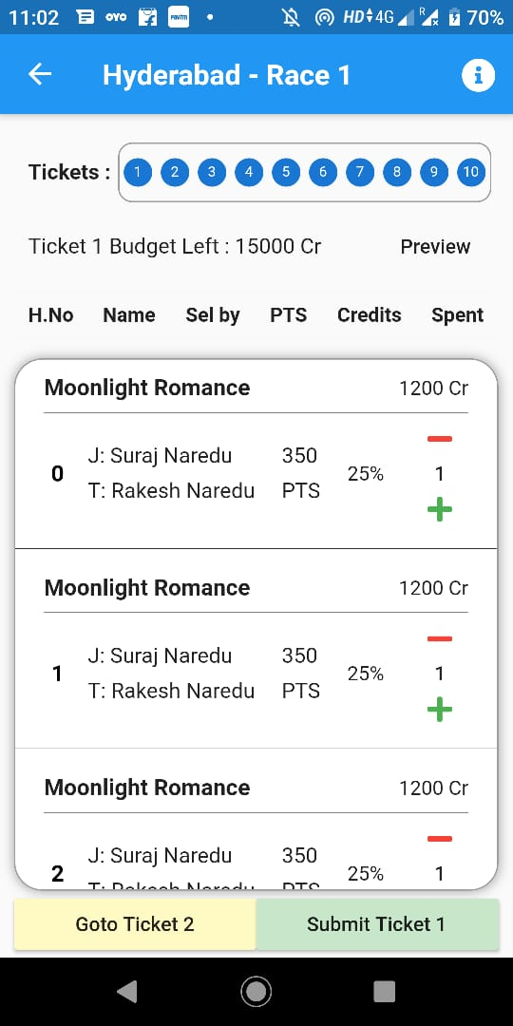

POST request to submit a ticket

What I need to send to the api to submit a particular ticket as per my understanding I have created an json

{

    "ticketId":1,

    "ticketBudgetSpent":1200,

    "horseId":[

        {

            "horseId":1

        },

        {

            "horseId":1

        }

    ]

}